Saluton

Specification
Write the source code for a simple application using eclipse and then compile and run the code.

Algorithm
- open main class
- print “Saluton Mondo” to the screen
- close main class

Flowchart
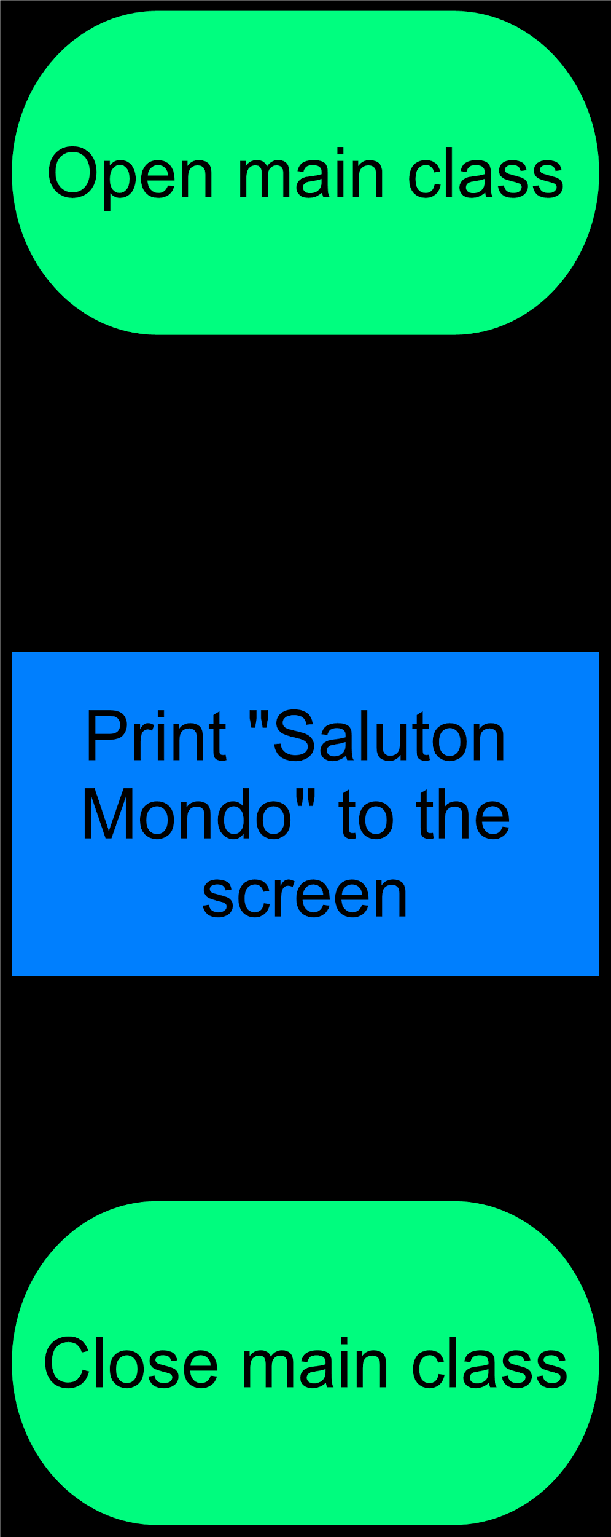

Code Design
System.out.println will be used to print Saluton Mondo to the screen.

Implementation

/*
* Saluton.java
* Max Rink
* ICS3U
* 25 September 2015
* A first Java application, display's a greeting
*/
package unit2;

/**
* The Saluton class displays a greeting.
*/

public class Lesson1SalutonMondo {

//start class definition

public static void main(String[] args) {

System.out.println("Saluton mondo!");

}
} //end class definition

Testing and Debugging
No errors were apparent in the program as the program is so short and straight forwards.

